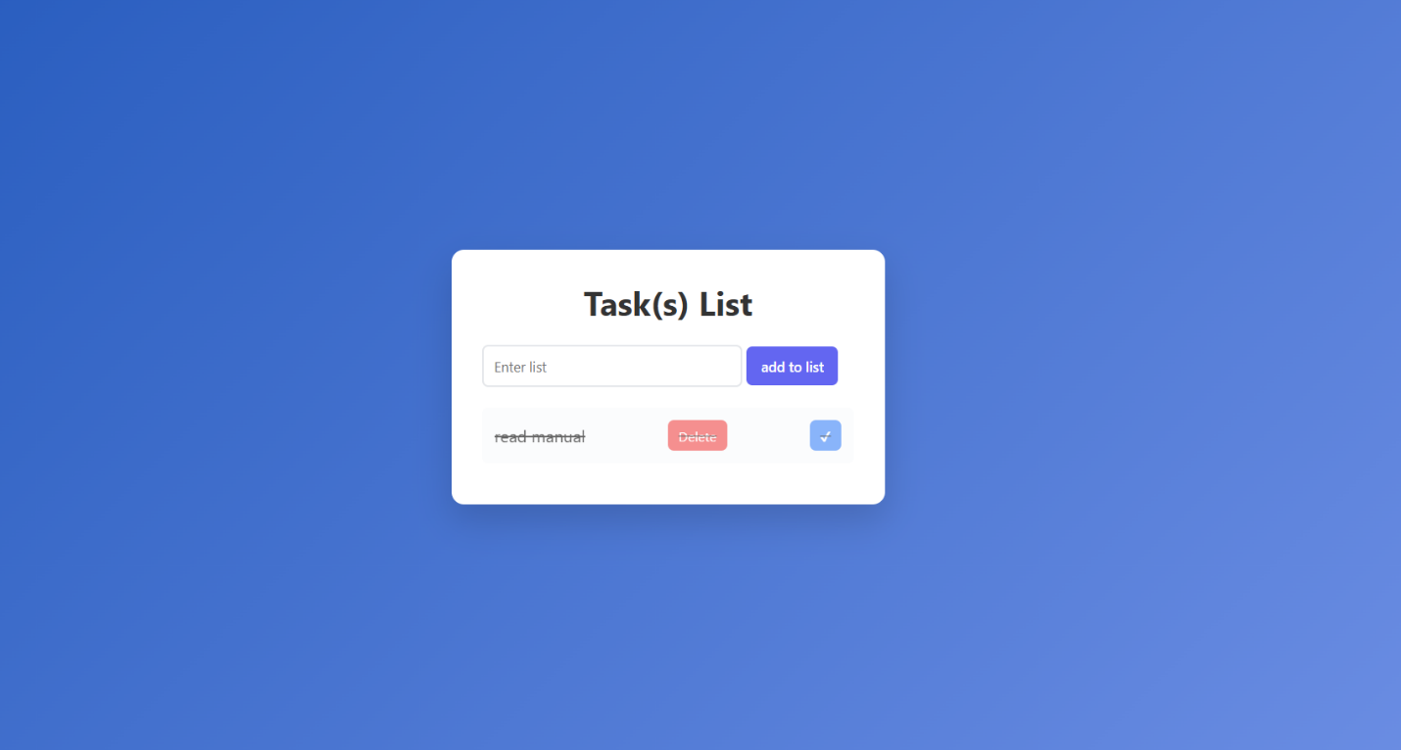
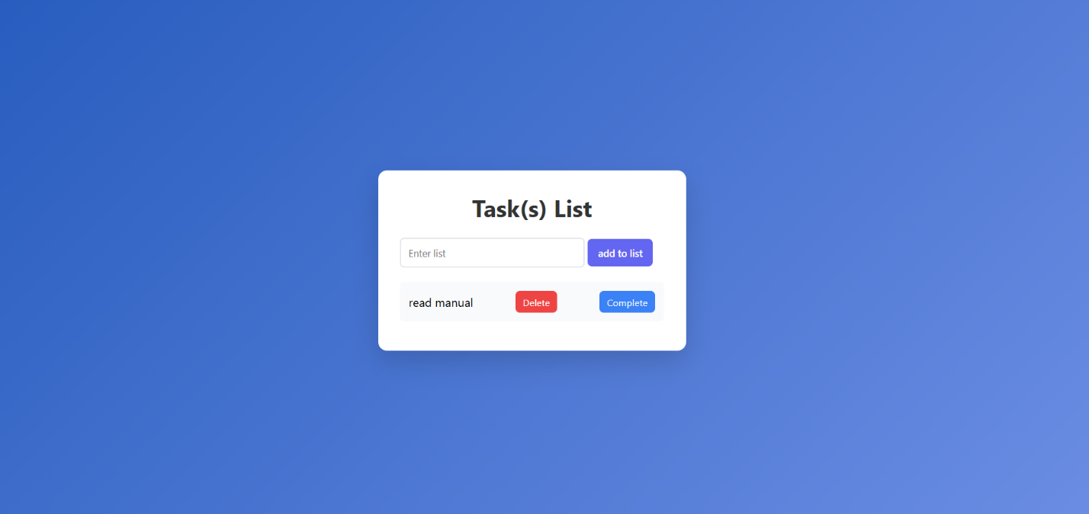
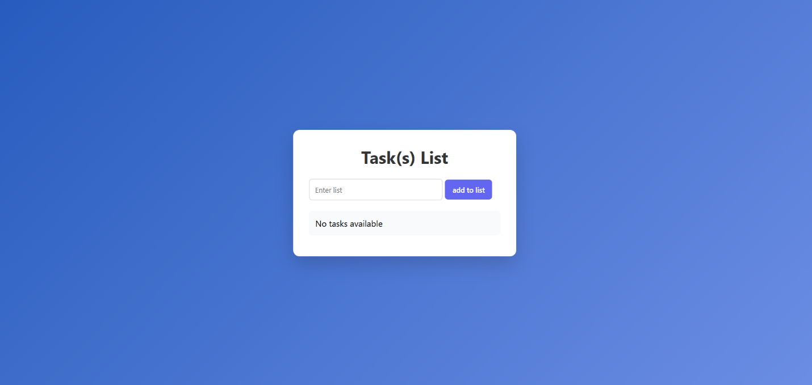
1. How does your application manage state?
The application manages state using a JavaScript array called tasks. Each task is an object with properties text and completed. Any addition, deletion, or completion update modifies this array. The array is also stored in localStorage so that the tasks persist when the page is refreshed. The tasks array is the single source of truth for the application.

2. Why is renderTasks() necessary after updating the array?
renderTasks() updates the DOM to match the current state of the tasks array. JavaScript arrays do not automatically update the HTML, so after adding, deleting, or completing a task, renderTasks() clears the existing list and creates new <li> elements for each task. Without it, the visible task list would not reflect the current state.

3. What is event delegation and why is it efficient?
Event delegation is a technique where a single event listener is added to a parent element (like the <ul>), and clicks on child elements (like buttons) are detected using event.target. It is efficient because:
- Only one listener is needed for all tasks.
- It works for dynamically added tasks.
- It reduces memory usage and simplifies code.

4. What happens if you manipulate the DOM but not the state?
If you change the DOM without updating the tasks array, the visual list and the application state become inconsistent. For example, deleting a <li> without removing the corresponding item in the array will cause the task to reappear on the next renderTasks() call or page reload. State must always be updated first, and the DOM should reflect the state.

